March 20, 2023

Dear Faculty and Staff,
A couple of weeks ago I sent out an update on the status of the budget. I hope the information was helpful. On March 15th a community budget forum was held. In case you missed it, I thought I would send you another update on how the process to develop the 2023-2024 budget is progressing.
The community budget forum was well attended…standing room only. I know the board appreciated the fact that so many people came out and gave their input. We are pleased but not surprised that so many people are passionate about the New Paltz Central School District.
As you may recall, the budget situation this year is not optimal. Based on our projections of revenue and expenses, we anticipate being $4,912,973 over budget.
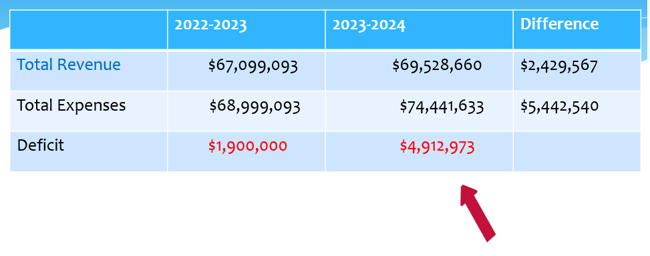
Making up an almost $5,000,000 deficit will not be easy or painless. At the budget meeting on March 1st the board was asked to consider the following reductions:
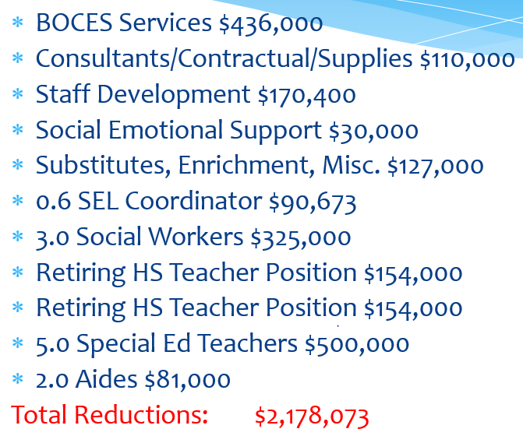
These reductions still leave the district short by $2,499,400.

At the budget forum on March 15th, it was noted that more solid special education numbers would necessitate adding back one of the special education positions that were being considered for reduction. This estimated cost of $100,000 added back into the budget increases our shortfall to $2,599,400.
Several additional ways of decreasing the budget were presented to the board. One factor affecting our ability to reduce positions is the projected size of elementary classes.
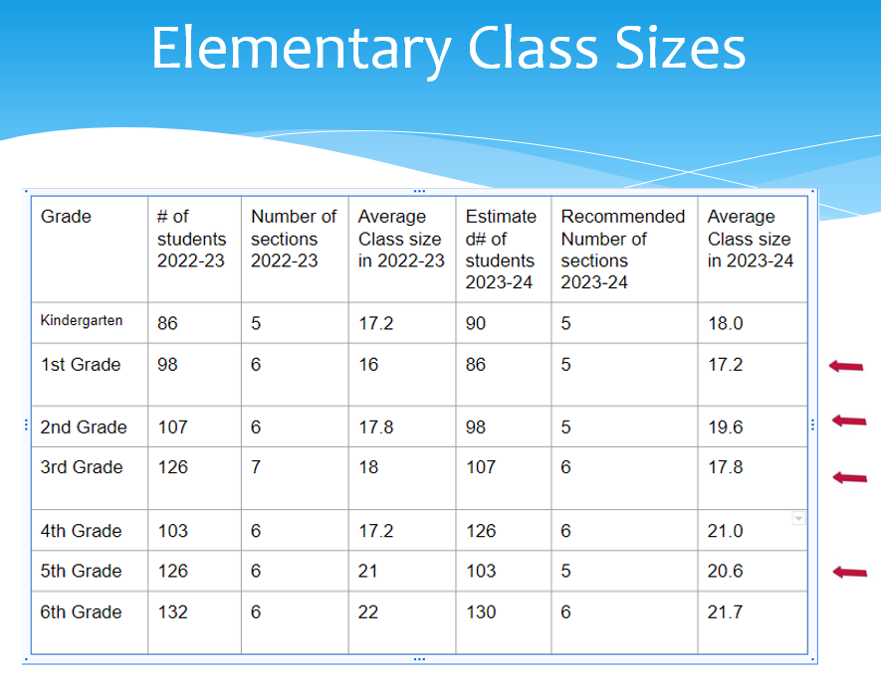
As you can see from this chart, our enrollment in the elementary buildings is projected to drop once again. In fact, it would be possible to eliminate a section of classes in 1st grade, 2nd grade, 3rd grade, and 5th grade without substantially increasing class sizes. In some cases the class size actually drops.
Reducing four elementary teachers would save the district $422,000.
A further consideration of the current year’s budget identifies other instructional and support positions that were never filled and remain unfilled. Eliminating these jobs, which we don’t need, will save an additional $200,000.
With the reductions listed above, the amount of money we still need to make up to balance the budget is $1,977,400.
During the budget presentation, I also suggested to the board that they consider reducing one foreign language position. This reduction would be in addition to the elementary foreign language position that was formerly housed in Duzine.
Eliminating a foreign language position would save the district $122,000. It was explained to the board that a full description of what instructional services would be lost if a foreign language teacher was eliminated would be provided at the next meeting. Saving $122,000 with this cut would bring the deficit down to $1,855,400.
After the budget presentation given by the Superintendent, those community members who attended the forum were given the opportunity to express their thoughts about the budget proposal. Many good points were made and the board fully considered their comments.
During the final stage of the budget meeting, the board deliberated on all that they had seen and heard during this discussion. The following topics were considered:
- The board expressed interest in bringing back the positions of the three social workers, for at least one more year, at a cost of $325,437. As a reminder, the social workers are currently paid for through the American Recovery Plan (ARP) grant. The board was informed that reducing counseling services from an outside company would cover $150,000 of the cost. Further reductions in ARP spending, since the board meeting, indicate that all $325,437 could be taken out of the ARP grant for an additional year.

- The board expressed an interest in having more information about the repercussions of reducing a language position. They were told that we would bring them more information on this topic at the next budget session. This information will allow them to make an educated decision on whether or not to eliminate the language position.

- The board expressed support for all of the other reductions brought forward including the elimination of four elementary positions, four special education positions, and two high school positions that will be vacant due to retirement.

- The board considered options for closing the $1,855,400 gap. One option is to use $1,855,400 of savings (fund balance) to balance the budget. Our fund balance at the end of last school year (June 30, 2022) was $2,908,045. Obviously, using $1,855,400 would greatly diminish our savings.

- The board considered ways to increase our fund balance back to a more fiscally responsible level. Discussion ensued about the appropriateness of seeking a “super majority” to raise the tax cap from 1.23 % to 3.36 % which would generate an extra $1,000,000 of revenue for the district. This $1,000,000 could be used to replenish reserve funds and to bring our fund balance back closer to the 4 % limit prescribed by law (fund balance/total tax levy). A budget requiring a super majority to pass would need 60 % of the voters to vote for the budget.

The budget forum concluded with the board members expressing an interest in examining any further ideas and information that we bring forward at the next budget meeting on March 29th and then officially adopting a budget at that meeting. When the budget is adopted, additional and more specific information about the budget will be shared with the community in preparation for the public hearing of the budget on May 3rd and the actual budget vote on May 16th.
I hope this description of the budget process is useful to you. We greatly appreciate input from the community as we work to develop the best plan for our students, school, and community. Please send any thoughts or questions to me and I will respond to them and share them with the school board.

Best Wishes,
Stephen Gratto - Superintendent

